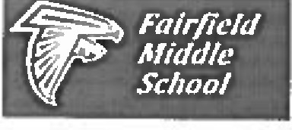
Fairfield Middle School
8th Grade Supply List

General Supplies (for all classes)
- 1 1 ½ inch binder with pockets and divider tabs for core classes
- 4-8 3-prong folders with pockets for core classes
- loose leaf paper (for binders)
- pencils and erasers
- black/blue ink pens
- markers /crayons /colored pencils
- hand-held pencil sharpener
- flash drive
- scissors
- dry erase markers
- composition books
- 1 subject notebook
- 2 5-subject spiral notebook (for math and history)
- glue sticks
- calculator
- graph paper
- 2 packs index cards (3x5 or
4x6)
- pair of headphones - optional
- box Ziploc baggies (for science)
- tissues and hand sanitizer (Please consider purchasing 1 box of tissues and 1 hand sanitizer for each class)
- Pack of sticky notes (for English)
- 2 1-subject notebooks (for English)
- Highlighters

Algebra/Geometry (if scheduled)
- 1.5 inch 3-ring binder (5-subject spiral notebook not required)

World History (if scheduled)
- 3-subject spiral notebook (5-subject spiral notebook not required)

Art (if scheduled)
- 1 sketchbook with plain white paper. Buy one bound by rings, not adhesive. (8 ½ X 11)

Chorus (if scheduled)
- ½-1" black 3-ring binder
- 10 3-hole punch plastic page holders (to keep music in)
- pencils and loose-leaf notebook paper

Chorus uniforms will need to be purchased in the fall through the school.

Band/Strings (if scheduled)
- Instrument/Supplies/Standard of Excellence Book (band director MUST be contacted to receive information, do not buy or rent without consulting band director)
- ½" soft, flexible binder in
blue/black
- 15 3-hole punch plastic page holders (to keep music in)
- 1 pencil (non-mechanical, no pens, to keep in instrument case)

Health Education and PE (all students)
- HPE Fee $6.00. Includes lock. Students must use school issued lock.
- Students must dress out in tennis shoes and athletic attire during PE - this is a requirement at FMS. (PE uniforms are optional) NO BODY SPRAYS.

Parents: Please note that general supplies are items used in every class. Your child needs enough of each item to last the entire school year. Additional supplies may be requested by individual teachers.

